
Course Code | : | SCST1223
Course Name | : | PROBABILITY AND STATISTICAL DATA ANALYSIS
Lecturer | : | Shamini A/P Raja Kumaran
Academic Session | : | 2025–2026 / Semester 2
Assessment Title | : | Project Report (Phase 2) — Inferential Statistical Analysis
Submission Due Date | : | Friday, 19 June 2026, 11:59 PM
Prepared by — Group 6
Matric No. | Student Name
A23CS4026 | Mohammed Mohsen Mohammed Alsakkaf (Group Leader)
A25CS4079 | Youssef Elsayed Abdelrazek Mahmoud Harraz
A25CS4065 | Qusai Mahmoud Ali Hijazi
A25CS4074 | Guo Siqi
A25CS4076 | Mohammed Esam

Assessment Mode | Group Project
Student Declaration
We hereby declare that this assessment is our own original work. Generative AI tools (the course Dr Quant assistant) were used only as explicitly permitted by the lecturer, and all such use is disclosed in the Appendix. All references used have been properly acknowledged.
Signatures:
1) ____________________ 2) ____________________ 3) ____________________
4) ____________________ 5) ____________________

TABLE OF CONTENTS
1. Introduction 3
2. Dataset 3
3. Data Analysis 4
3.1 Two-Sample t-Test — Focus by Gender 5
3.2 Pearson Correlation — Intake vs Sleep 6
3.3 Simple Linear Regression — Sleep on Intake 6
3.4 One-Way ANOVA — Effect Duration by Level 7
3.5 Goodness-of-Fit — Beverage Preference 8
4. Conclusion 9
5. Appendix 11
References 12

1. Introduction
Caffeine is among the most widely consumed psychoactive substances on university campuses, and at Universiti Teknologi Malaysia (UTM) it is woven into the daily academic routine of students who rely on it to stay alert through demanding schedules. In Project Phase 1 we described the caffeine-consumption habits of 74 UTM undergraduates using descriptive statistics. Phase 2 advances from description to inference: we now test whether the patterns observed in Phase 1 are statistically significant, and what they imply about the relationship between caffeine intake, sleep quality, and academic focus.
Purpose. The study investigates three questions: (i) whether daily caffeine intake is statistically associated with self-reported sleep quality; (ii) whether the perceived duration of caffeine's effect differs across levels of consumption; and (iii) whether students' beverage preferences are evenly distributed. We were motivated by a familiar sight in the campus library — peers studying late on repeated cups of coffee — and wanted to establish whether the habit measurably helps focus or harms sleep.
Expectations. Drawing on Phase 1's right-skewed consumption profile and on published evidence that caffeine prolongs sleep latency and lowers perceived sleep quality (Drake et al., 2013; Clark & Landolt, 2017), we expected higher intake to be associated with poorer sleep, a positive relationship between intake and the duration of caffeine's perceived effect, and a strongly uneven preference dominated by coffee.
Structure. Section 2 describes the dataset and the pre-processing applied; Section 3 reports five inferential tests — a two-sample t-test, a correlation, a regression, a one-way ANOVA, and a goodness-of-fit test; Section 4 draws the findings together; and the Appendix documents our use of the Dr Quant AI assistant, provides raw and processed data samples, and gives the project video link.

2. Dataset

2.1 Source and Sample
The analysis uses the same primary dataset collected in Phase 1 through a structured Google Forms questionnaire distributed via UTM student WhatsApp and Telegram channels. Of the 74 responses received, 55 respondents are regular caffeine consumers; these form the analysis sample for all consumption-dependent measures, while the 19 non-consumers are retained in the raw file but excluded from the consumption-based tests.

2.2 Data Pre-processing and Filtering
- Filtering. Records were filtered to regular consumers (n = 55) for every consumption-dependent variable, because cups per day, focus, effect duration, and sleep impact are undefined for non-consumers. Non-consumers were removed list-wise from those tests.
- Measurement-level corrections. Following the lecturer's Phase 1 feedback, we (a) removed the duplicated “type of caffeine” question so each respondent carries a single caffeine_type, (b) removed the “Others” option from numeric items so that cups_per_day is a clean ratio count, and (c) clarified the focus (1–10) and sleep-impact (1–5) scales as ordered numeric scales treated as interval for parametric analysis.
- Recoding. Cups per day was recoded into an ordinal consumption_level (Low ≤ 1, Moderate = 2, High ≥ 3) to enable group comparison.
- Validation. Ranges were checked for impossible values; none were found, and no missing values remained among the 55 consumers.

2.3 Variables and Levels of Measurement
Variable | Role | Level | Description
gender | Grouping | Nominal | Respondent gender (Male / Female)
caffeine_type | Grouping | Nominal | Preferred beverage (Coffee, Tea, Energy, Soda, Soft)
consumption_level | Grouping | Ordinal | Low ≤ 1, Moderate = 2, High ≥ 3 cups/day
cups_per_day | Predictor | Ratio | Caffeinated drinks consumed per day (count)
focus_score | Outcome | Interval | Self-rated focus after caffeine (1–10)
effect_duration_hr | Outcome | Ratio | Hours the caffeine effect is felt
sleep_impact | Outcome | Ordinal | 1 = strongly worsens sleep … 5 = strongly improves

2.4 Rationale and Expected Outcomes
cups_per_day is the central exposure variable; sleep_impact and focus_score are the health and cognition outcomes the study cares about; effect_duration_hr adds a dose-response dimension; gender enables a demographic contrast that directly probes the Phase 1 sampling bias; and caffeine_type supports a preference test. Based on the literature we expected a negative intake–sleep association, an effect duration that rises with intake, a coffee-dominated preference, and — given the very small female subsample — only a cautiously interpreted gender contrast.

2.5 Note on Representativeness
As flagged after Phase 1, the sample is dominated by Year 1 students, male respondents, and students from the Faculty of Computing. This demographic skew limits generalisability, so all inferential results below are interpreted as applying primarily to this population, and the small female subsample (n = 9) is explicitly weighted in the discussion of the gender test.

3. Data Analysis
All tests were performed in R at a significance level of α = 0.05. In line with the project instructions, no R code is reproduced here; the full script is submitted as a separate file. For each test we define the variables, state the hypotheses in words and in mathematical terms, report the test statistic and p-value, and interpret the result.
Analytical approach and assumptions. Before testing, the assumptions behind each method were checked. Levene’s test confirmed unequal variances in focus between genders (W = 7.24, p = 0.01), so a Welch correction was applied to the t-test; the consumption-level groups, by contrast, showed homogeneous variances for the ANOVA (Levene W = 0.81, p = 0.45). The regression residuals were approximately normal (Shapiro–Wilk p = 0.06), and every expected cell count in the goodness-of-fit test equalled 11 (≥ 5), satisfying its validity condition. Minor departures from normality in the smallest subgroups were noted but do not materially affect the conclusions, given the robustness of these procedures.

3.1 Two-Sample t-Test — Focus Level by Gender
Variables. Dependent: focus_score (interval, 1–10). Independent: gender (nominal, two groups).
Hypotheses. H₀: μ_Female = μ_Male (mean focus is equal across genders). H₁: μ_Female ≠ μ_Male.
Execution. A Welch two-sample t-test (unequal variances, justified by Levene’s test, p = 0.01) was used. The worked statistic is shown below; the mean difference (F − M) is 1.57 with 95% CI [0.67, 2.46].
Group | n | Mean | SD
Female | 9 | 8.00 | 0.87
Male | 46 | 6.44 | 2.24
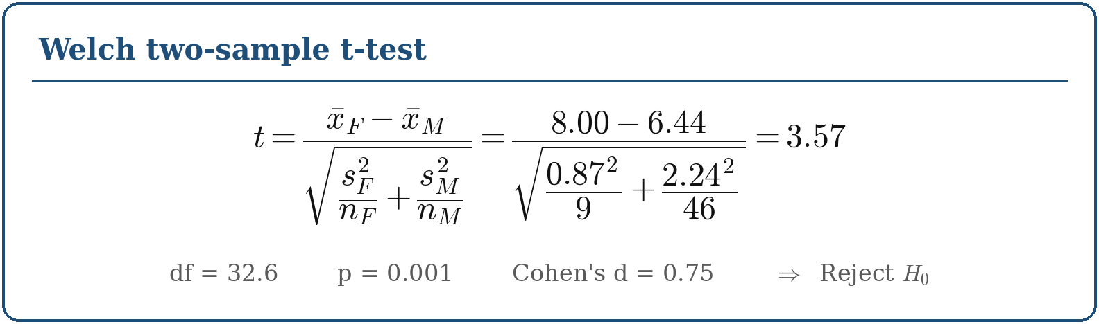
Interpretation. Because p < 0.05, we reject H₀. In this sample, female consumers reported significantly higher focus than males, and the effect is large (d ≈ 0.75). In real-world terms, the women surveyed rated their post-caffeine focus both higher and more consistently. This estimate is, however, based on only nine female respondents and carries a wide confidence interval, so it should not be generalised — it illustrates precisely the demographic-bias limitation noted after Phase 1.
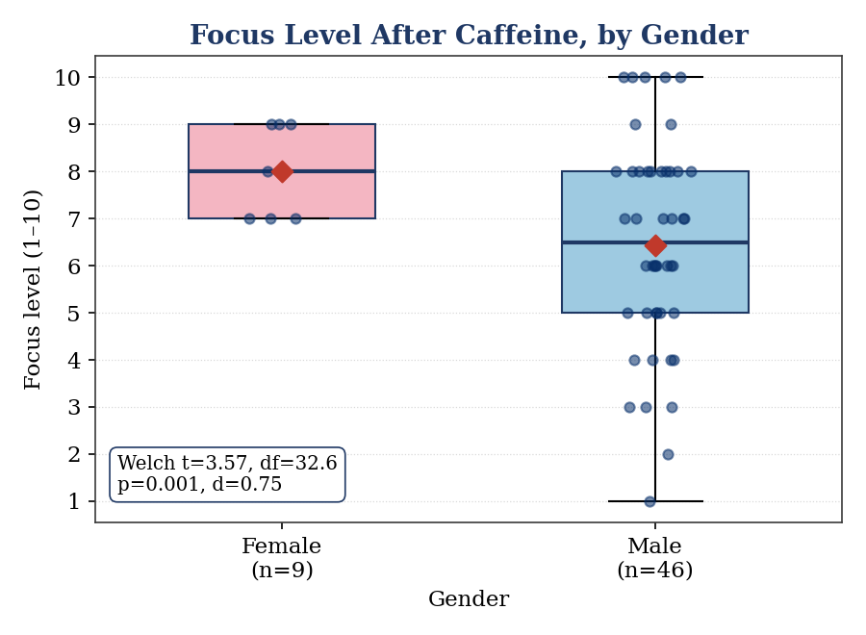
Figure 3.1 — Focus level after caffeine, by gender (diamonds mark group means).

3.2 Pearson Correlation — Caffeine Intake vs Sleep Quality
Variables. cups_per_day (ratio) and sleep_impact (1–5, higher = better sleep).
Hypotheses. H₀: ρ = 0 (no linear association). H₁: ρ ≠ 0.
Execution. Pearson’s r and its significance test are worked below; the 95% confidence interval for ρ is [−0.74, −0.38].
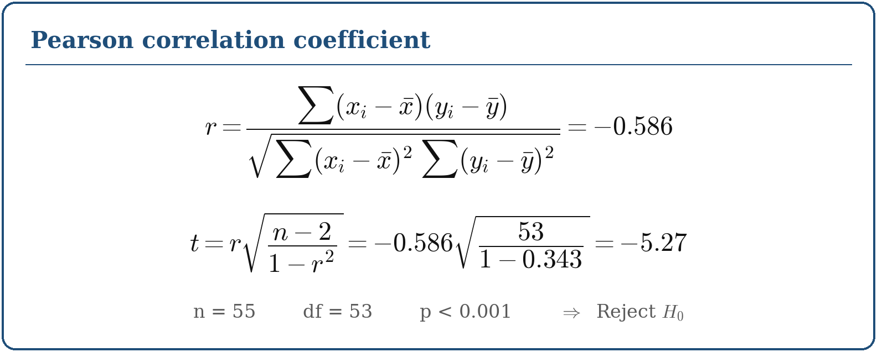
Interpretation. We reject H₀: there is a moderate-to-strong negative linear association. As daily caffeine intake rises, self-reported sleep quality falls. The coefficient of determination r² = 0.34 indicates that about 34% of the variation in sleep impact is shared with intake — consistent with the systematic-review evidence that caffeine lowers perceived sleep quality (Clark & Landolt, 2017). The relationship is visualised together with the regression line in Figure 3.2.

3.3 Simple Linear Regression — Sleep Impact on Caffeine Intake
Variables. Dependent: sleep_impact. Independent: cups_per_day.
Model and hypotheses. sleep_impact = β₀ + β₁·cups_per_day. H₀: β₁ = 0. H₁: β₁ ≠ 0.
Execution. Least-squares estimation yields the fitted model shown below (slope SE = 0.13; adjusted R² = 0.33). The model predicts a sleep-impact score of 2.9 at 2 cups/day and 0.9 at 5 cups/day.
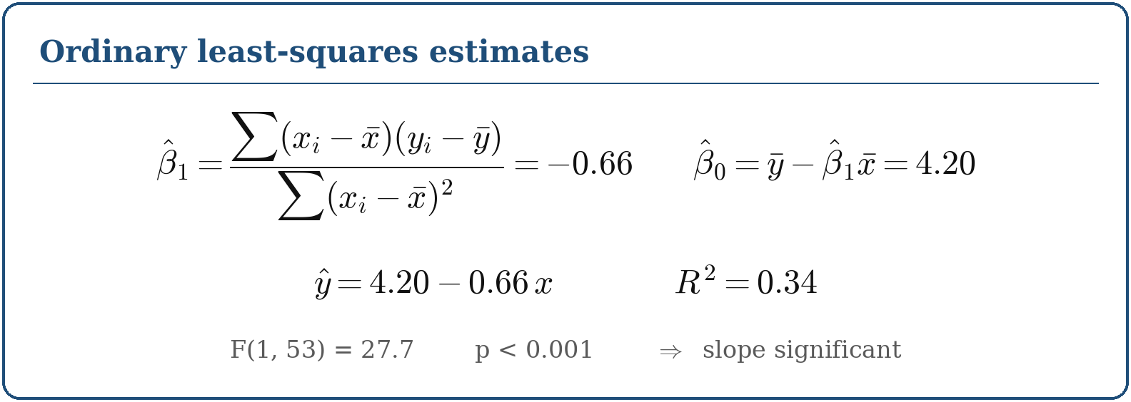
Interpretation. We reject H₀. Each additional cup per day is associated with a 0.66-point decrease in the sleep-quality score, and the model explains roughly 34% of the variance — a meaningful share for self-reported behavioural data, though the unexplained majority signals that other factors (consumption timing, stress, individual tolerance) also matter. The negative slope provides the clearest single confirmation of the study’s central concern. We describe this as an association and do not claim causation, since the data are observational.
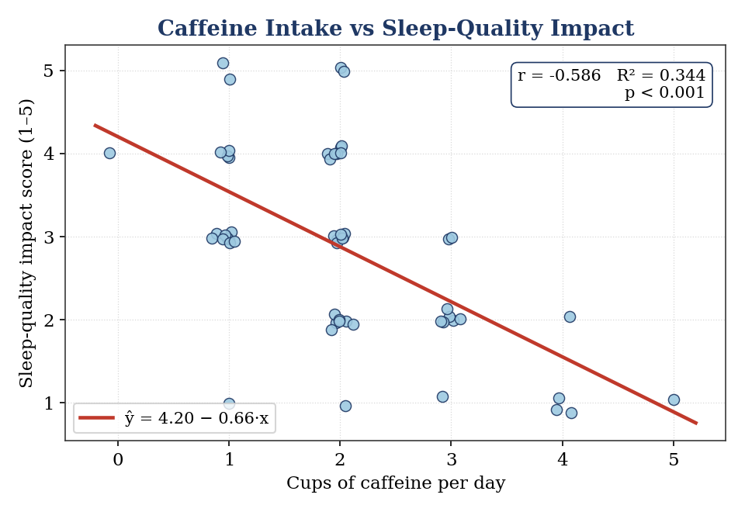
Figure 3.2 — Scatter plot of sleep impact against cups per day with fitted regression line (r = −0.59, R² = 0.34).

3.4 One-Way ANOVA — Effect Duration across Consumption Levels
Variables. Dependent: effect_duration_hr (ratio). Factor: consumption_level (Low / Moderate / High).
Hypotheses. H₀: μ_Low = μ_Moderate = μ_High. H₁: at least one group mean differs.
Consumption level | n | Mean (hrs) | SD
Low (≤1) | 17 | 2.06 | 1.44
Moderate (2) | 24 | 2.96 | 1.52
High (≥3) | 14 | 5.21 | 1.72
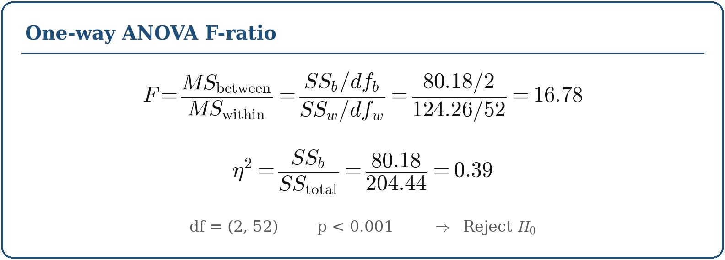
Post-hoc (Tukey HSD). High vs Low (Δ = 3.16, p < 0.001) and High vs Moderate (Δ = 2.26, p < 0.001) differ significantly; Low vs Moderate does not (p = 0.17).
Interpretation. We reject H₀: perceived effect duration differs across consumption levels, driven by High consumers feeling the effect markedly longer (about 5 hours versus 2). The effect size η² = 0.39 is large. This grouped result corroborates the regression with a dose-response reading: heavier consumers experience longer-lasting effects, which plausibly feeds the late-day intake that undermines sleep.
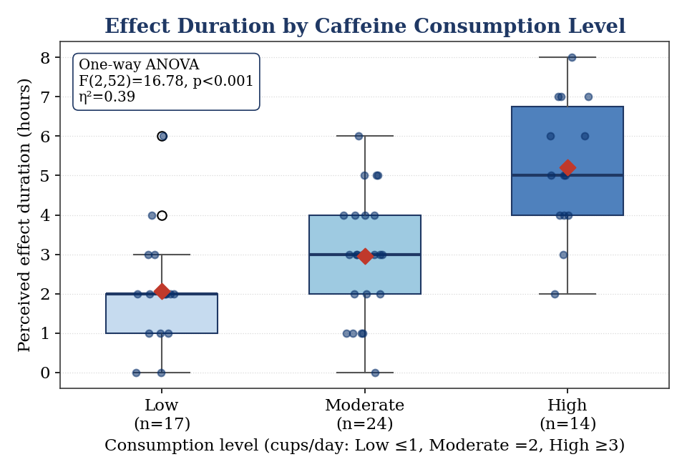
Figure 3.3 — Effect duration by consumption level; effect duration rises sharply for High consumers.

3.5 Chi-Square Goodness-of-Fit — Beverage Preference
Variable. caffeine_type (five categories).
Hypotheses. H₀: the five types are equally preferred (each p = 0.20). H₁: preferences are not uniform.
Execution. The observed counts (26 / 14 / 7 / 5 / 3) are compared with an expected count of 11 per cell:
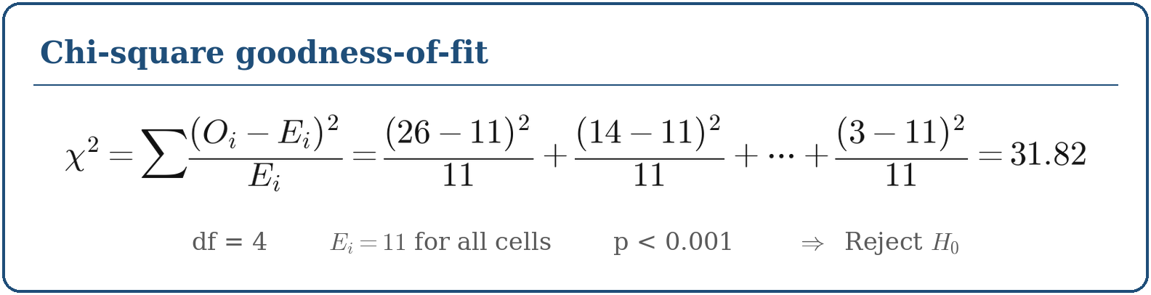
Interpretation. We reject H₀: preferences are far from uniform, with coffee (47%) and tea (25%) dominating. In practical terms, any campus initiative addressing caffeine and sleep should focus on coffee and tea drinkers, who together account for nearly three-quarters of consumers.
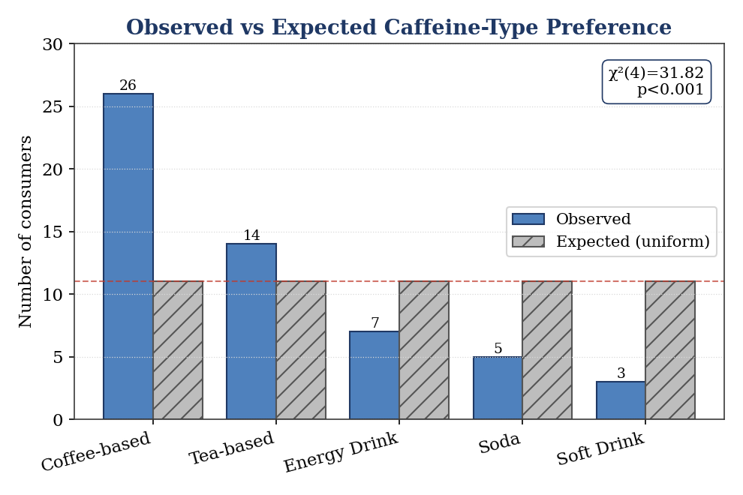
Figure 3.4 — Observed beverage preferences versus the uniform expectation (dashed line).
Table 3.1 — Summary of inferential results and decisions (α = 0.05)
Test | Variables | Statistic | p-value | Decision
1. Two-sample t-test | Focus × gender | t = 3.57 | 0.001 | Reject H₀
2. Pearson correlation | Cups vs sleep | r = −0.59 | < 0.001 | Reject H₀
3. Linear regression | Sleep ~ cups | F = 27.7, R² = 0.34 | < 0.001 | Reject H₀
4. One-way ANOVA | Effect dur. × level | F = 16.78 | < 0.001 | Reject H₀
5. Goodness-of-fit | Beverage type | χ² = 31.82 | < 0.001 | Reject H₀

4. Conclusion
Across five inferential tests, Phase 2 turns the descriptive picture of Phase 1 into statistically supported findings. The strongest and most interesting result is the clear negative relationship between caffeine intake and sleep quality: it appears as a significant correlation (r = −0.59), is quantified by regression (each extra cup lowers the sleep score by 0.66 points, R² = 0.34), and is reinforced by the ANOVA showing that heavy consumers feel caffeine’s effect far longer — a plausible mechanism for disturbed sleep. The goodness-of-fit test confirms that consumption is concentrated in coffee and tea, and the gender t-test surfaces an intriguing but underpowered difference in self-reported focus.
Methodologically, the group learned to match each inferential test to the measurement level of its variables, to state hypotheses formally, to read p-values and effect sizes together, and to keep interpretive language cautious — reporting associations rather than claiming proof. The principal limitation, consistent with the lecturer’s Phase 1 comment, is the sample’s demographic skew toward Year 1, male, and Computing students; the gender finding in particular should be read as suggestive only. Future work would benefit from a larger, more balanced sample and from measuring sleep with a validated instrument rather than a single self-report item.

5. Appendix

Appendix A — Reflection on the Use of the Dr Quant AI Assistant
Throughout Phase 2 the group used Dr Quant, the course’s AI statistics assistant, as a study aid rather than an answer key. We applied it in three concrete ways. First, we described our variables and their measurement levels and asked which inferential test suited each pairing; this confirmed that a Welch t-test fitted the focus-by-gender comparison (unequal group sizes and variances) and encouraged us to pair the correlation with a regression for the intake–sleep relationship rather than reporting a correlation alone. Second, when our first R run failed on the blank cells belonging to non-consumer rows, we pasted the error message and Dr Quant helped us trace it to NA handling, after which we added na.strings and list-wise filtering. Third, we asked it to sanity-check our wording of the results, and it flagged that we had initially written “we proved caffeine causes poor sleep”; we corrected this to associational language.
Critically, we did not accept outputs blindly. We re-ran every statistic in R ourselves and compared the numbers, and we rejected one suggestion — to drop the small female group entirely — because doing so would have concealed the very sampling-bias limitation the lecturer asked us to address. All AI assistance is disclosed here in line with the course policy; the analysis, code, and writing remain our own. Screenshots of the key Dr Quant outputs are inserted below.
[ Insert screenshots of the Dr Quant conversation here — capture the outputs referred to above. ]

Appendix B — Sample of Raw and Processed Data
Raw data (as collected) — non-consumers leave consumption fields blank:
ID | Gender | Year | Regular? | Type | Cups | Focus | Sleep
1 | Male | Year 1 | Yes | Coffee-based | 5 | 9 | 1
2 | Male | Year 1 | Yes | Energy Drink | 3 | 10 | 2
56 | Male | Year 1 | No | —
57 | Female | Bridging | No | —
Processed data (analysis sample) — consumers only, with derived consumption level:
ID | Gender | Type | Cups | Focus | Effect (h) | Sleep | Level
1 | Male | Coffee-based | 5 | 9 | 4 | 1 | High
2 | Male | Energy Drink | 3 | 10 | 7 | 2 | High
3 | Male | Tea-based | 3 | 10 | 4 | 2 | High
12 | Female | Coffee-based | 1 | 8 | 2 | 4 | Low
The complete dataset (74 records) is provided as caffeine_dataset.csv in the submission folder.

Appendix C — Project Video
LinkedIn video URL: [ Insert public LinkedIn video URL here ]
The video presents the project topic and key findings; all five group members are tagged, and the post is set to public access as required.

References
Clark, I., & Landolt, H. P. (2017). Coffee, caffeine, and sleep: A systematic review of epidemiological studies and randomized controlled trials. Sleep Medicine Reviews, 31, 70–78.
Drake, C., Roehrs, T., Shambroom, J., & Roth, T. (2013). Caffeine effects on sleep taken 0, 3, or 6 hours before going to bed. Journal of Clinical Sleep Medicine, 9(11), 1195–1200.
UTM Faculty of Computing (2026). SCST1223 Probability and Statistical Data Analysis — Project Guidelines (Phase 2).

